Appendix 1: Brief introduction of Educational Committee members
recommended
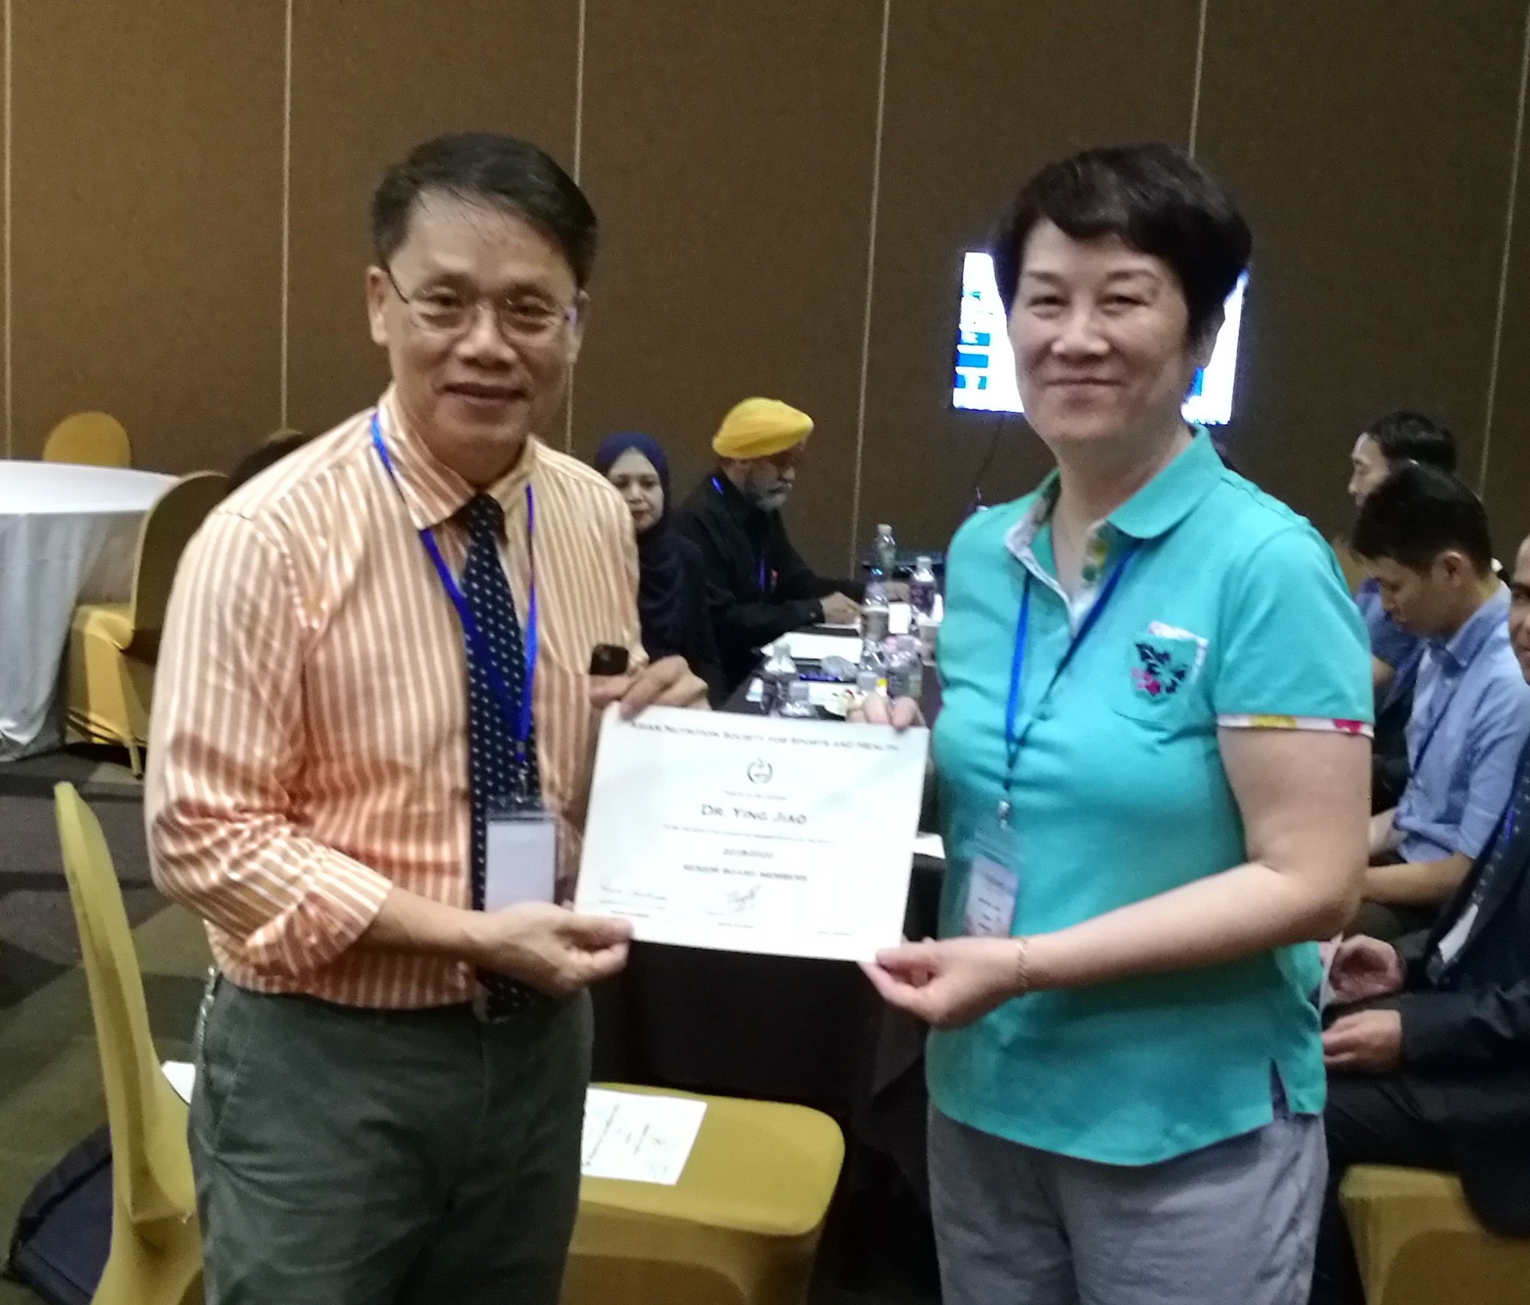
1, Ying Jiao （Chair for Educational Committee of ANSSH）
President, China Sports Nutrition & Food Society of CIFST, Deputy general manager, Beijing Competitor Sports Science & Technology Co., Ltd, Member, Executive Committee for Asia Nutrition Society for Sports & Health.
She engaged in sports nutrition and biochemistry for forty years, participated in more than 10 national research projects, received more than 10 ministerial awards. She published more than 40 research papers and 6 books at home and abroad. She studied as a PhD student in the Department of Clinical Physiology, Karolinska University, Sweden. After returning to China, she participated in the establishment of Beijing Competitor Sports Science & Technology Co., Ltd and Sports Nutrition Institute. After nearly 20 years of experience, this company has become famous entrepreneurs of science and technology.

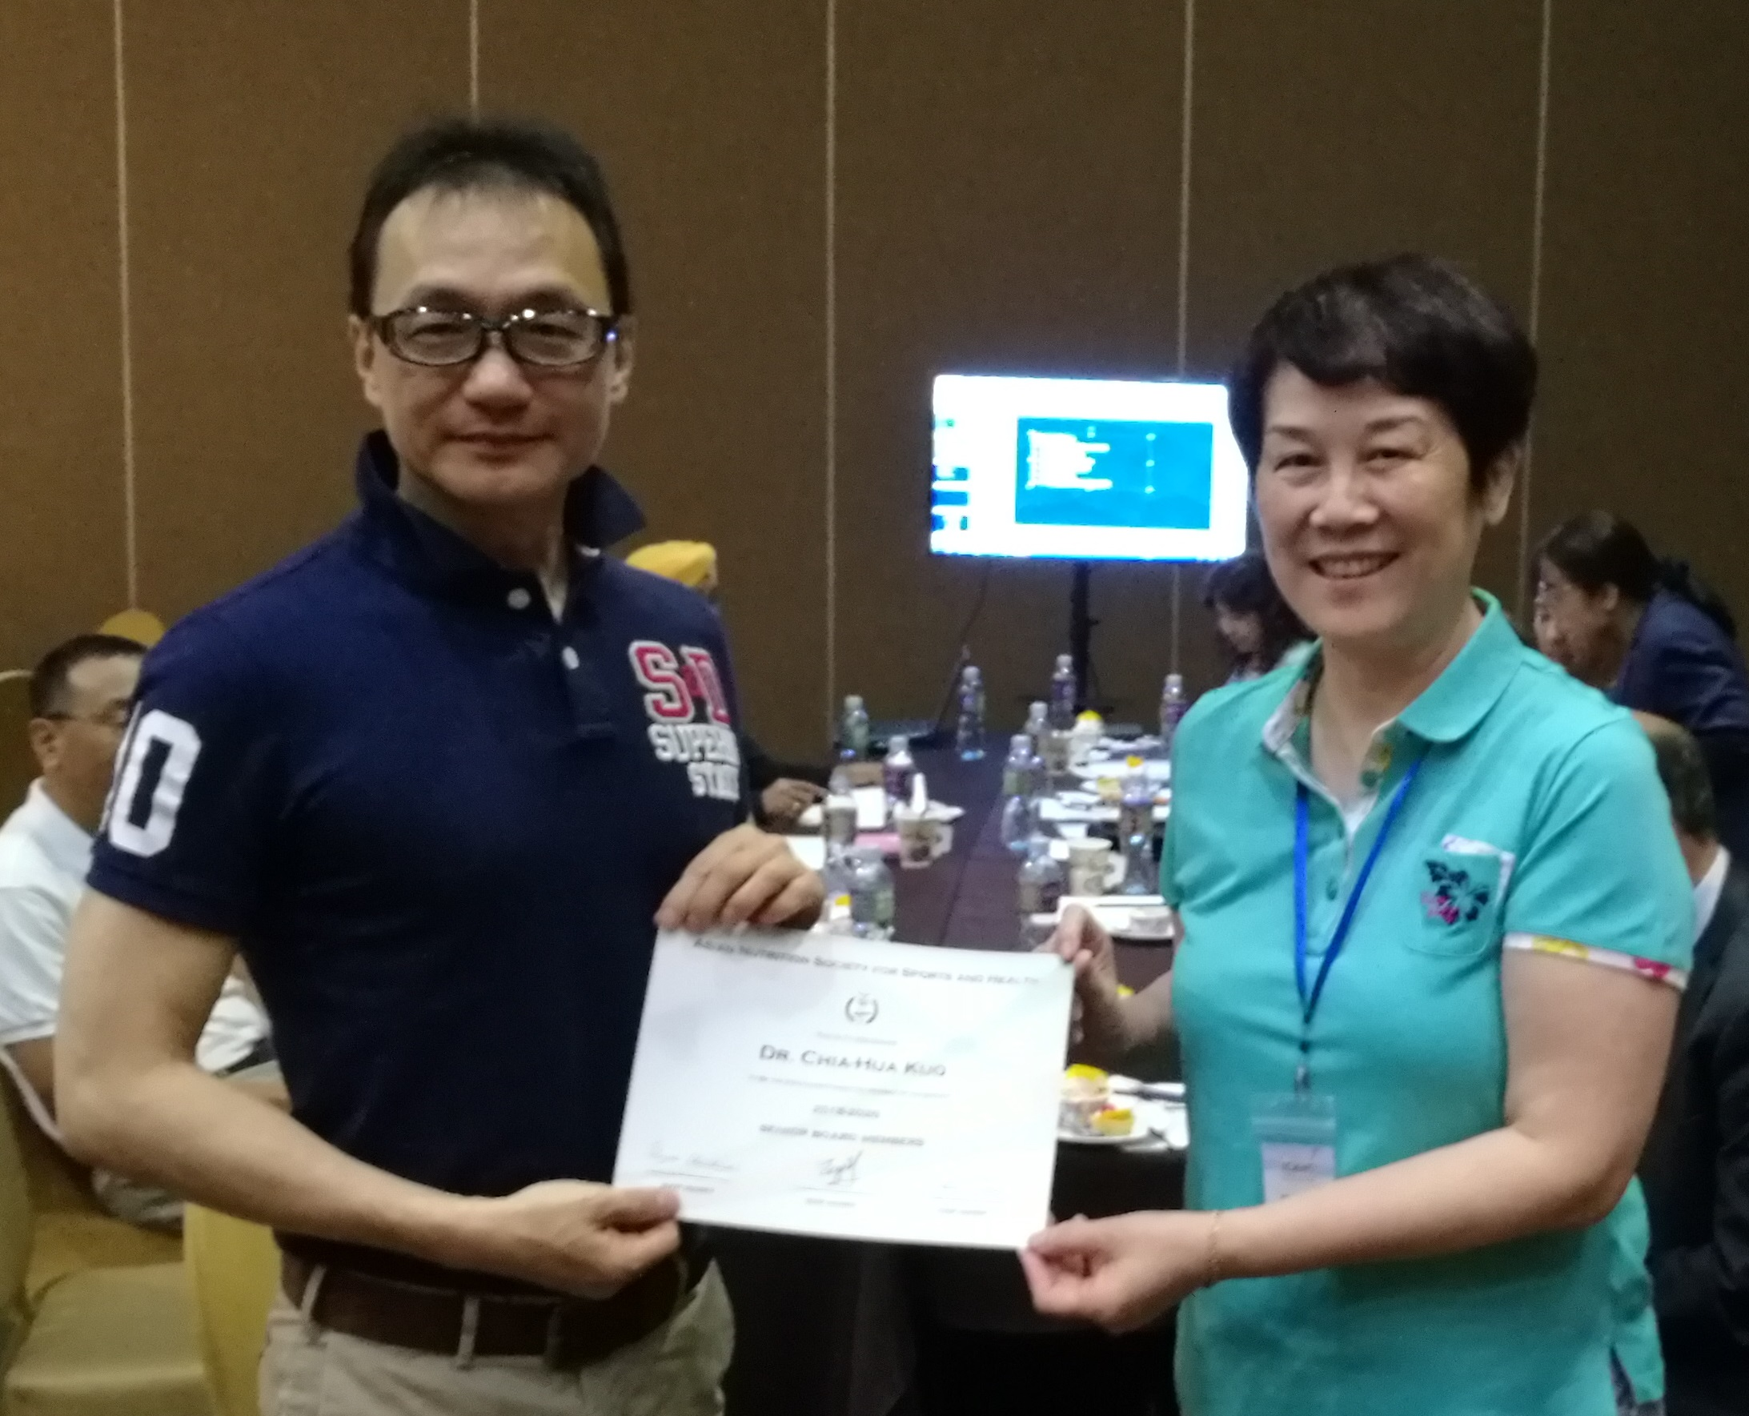
2, Chia-Hua Kuo
Dr. Chia-Hua Kuo is a distinguished professor at University of Taipei and the President of Taiwan Society for Sports Nutrition. He specializes in exercise and nutritional impacts on muscle inflammation.

3, Rungchai Chaunchaiyakul
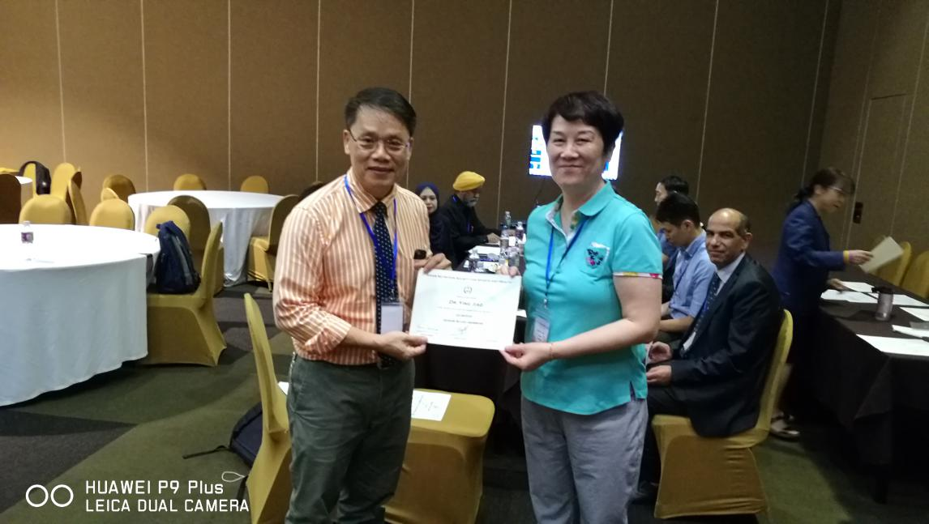
Dr. Rungchai Chaunchaiyakul is the President Elect of ANSSH and an associate professor in Mahidol University. He is currently the academic consultant for The Sports Authority of Thailand. A former manager for Exercise is medicine in Thailand (supported by EIM, The American College of Medicine) and former secretary of Thai Without Big Belly Campaign, Thai Health Foundation. He is specialized in thermal physiology and sports drinks.

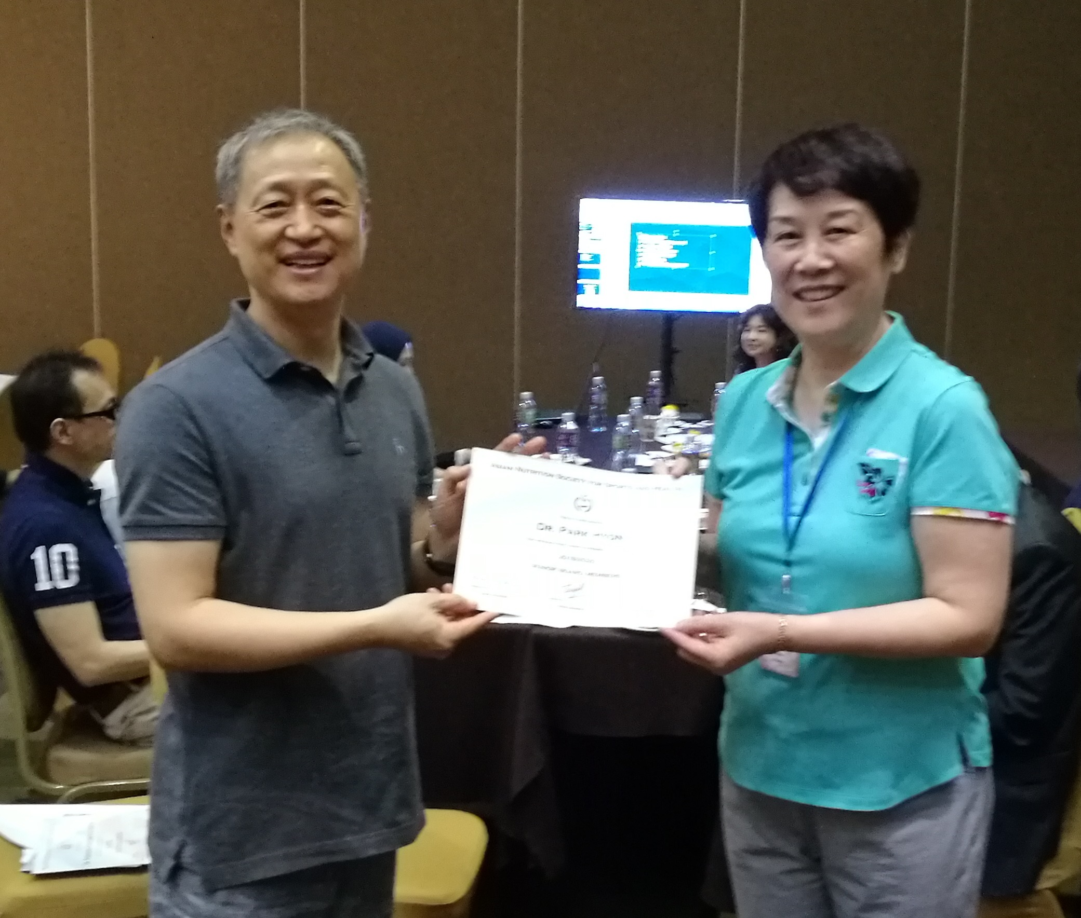
4, Park Hyon
Dr. Park Hyon is the an professor and Deputy Dean for Kyung Hee University. He was associate editor for Journal of Exercise Nutrition and Biochemistry.

5, Lee Kai Wei Jason
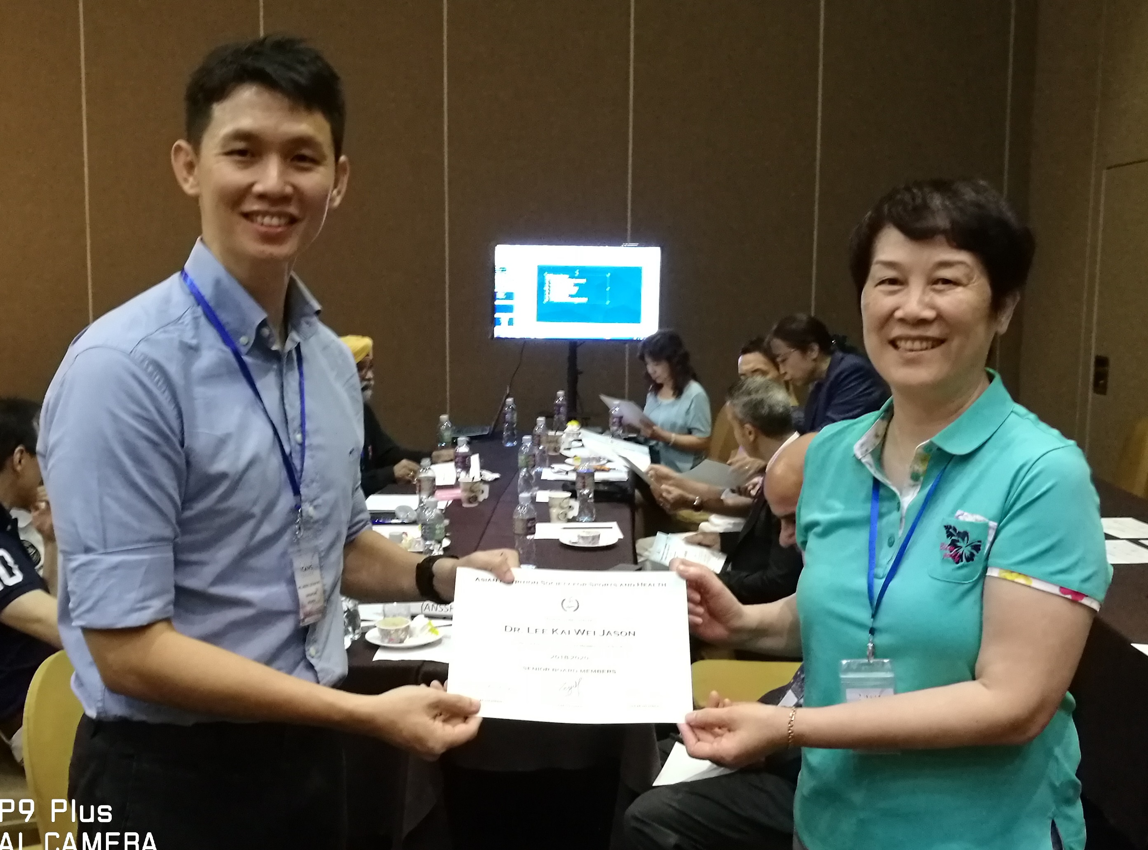
Dr. Lee is an Associate Professor at the Yong Loo Lin School of Medicine, National University of Singapore. He specializes in fluid balance, thermal physiology and applied human performance. He is also a faculty member of the International Olympic Committee Diploma in Sports Nutrition.

6, Ahmad Alkhatib
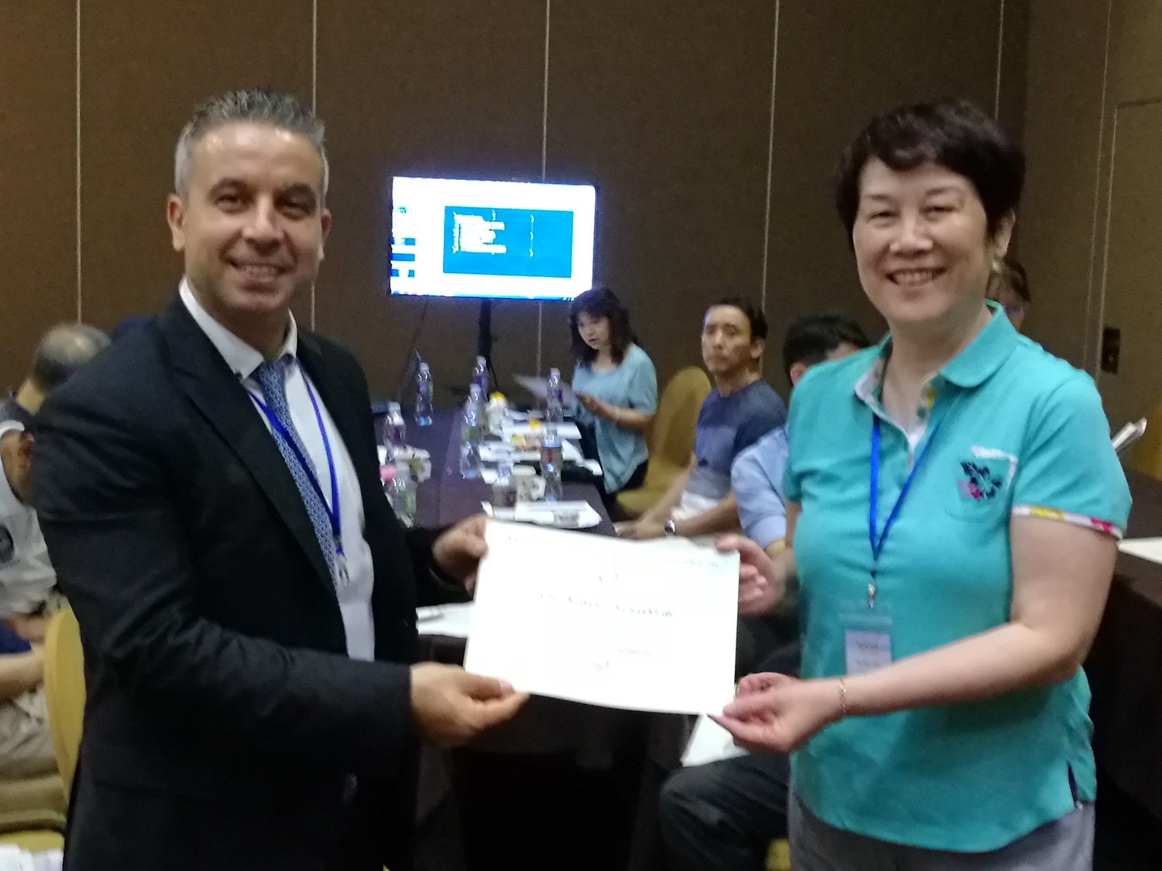
Ahmad Alkhatib is the Head of Division of Sport and Exercise Science at Abertay University in the UK. He is a Fellow of the Royal Society of Medicine, an accredited UK nutritionist (RNutr), a clinical physiologist, a certified international sports nutritionist (CISSN), and also a Fellow of the UK Higher Education Academy (FHEA). He was awarded his PhD in Exercise Physiology and Metabolism, and MSc in Exercise Sciences (Health and Fitness) from the University of Essex, UK.
His research in exercise and nutritional sciences focuses on novel techniques to enhance health outcomes especially those combining nutraceutical, with physical activity to enhance metabolic health, weight loss and disease prevention. He has over 100 publications and won several research and academic excellence awards.

